Customer Journey Map

Awareness | Consideration | Decision | Service | Loyalty

Customer Actions
Add an activity that your customer does for each phase

Customer Actions
Add a touchpoint for each phase (example: website, email, social media, etc.)

Customer Actions

curious, excited

excited

frustrated

satisfied, happy

interested, hesitant
Negative Positive

Customer Actions
Add a pain point your customer has for each phase

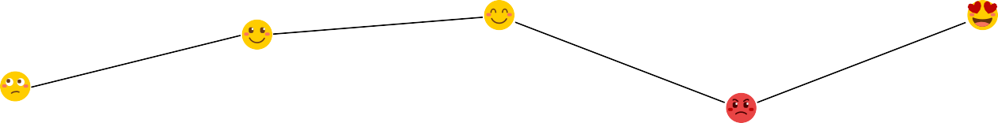

Customer Actions

Add a solution for each phase

